Damian Valdez
Account Executive, Florida Panthers
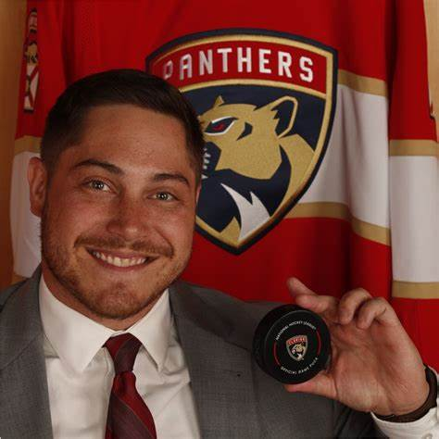
Damian Valdez enlisted in the U.S. Navy in 2016 as an Electricians Mate (Nuclear) with 15 months of sea time serving aboard two Virginia Class fast attack submarines responsible for reactor operations, electrical power generation/distribution, and shipboard electrical equipment. He was the RPOC (Recruit Chief Petty Officer) in his boot camp division which consisted of leading 86 sailors to graduation in bootcamp. He then attended the infamous ‘Nuclear Pipeline’ to become a nuclear reactor operator. First up was Nuclear Field “A” School in Charleston, SC which consisted of learning the intricate methods of Electrical engineering designed by MIT. Following graduation, he attended Nuclear Power School (NPS) in Charleston, SC where students learned the dynamic complexities of Nuclear Engineering and design. Upon graduating, he attended Nuclear Prototype which consisted of becoming a certified nuclear reactor plant operator onboard a S5G live nuclear reactor plant by the Department of Energy (DOE). He then spent time as a nuclear instructor certifying students at Nuclear Power School. Upon his Staff tour, he served abord the PCU Indiana (SSN 789) in Norfolk, VA conducing Alpha, Bravo, and Charlie Sea trials to commission her and became certified on an S9G reactor. Shortly after becoming a plank owner, he was transferred to the USS Washington (SSN 787) embarking on pre-deployment workups and her maiden EUCOM deployment to the North Arctic region focusing on Russian deterrence and intelligence. After 22 successful missions and POTUS’s authorization for extensions, the USS Washington was awarded the title for tracking the most foreign submarines on a single deployment. Following his sea tour, he assisted in reactor division ashore at Submarine Squadron 6 in Norfolk, Virginia.

He has since joined the of Florida Panthers in January of 2023 after completing his time in service and obtaining his bachelor’s degree in criminal justice from Nova Southeastern University. Damian is currently an Account Executive on the New business sales team after being the first to be promoted within from the C.A.T.S. Academy (career advancement in ticket sales) inside sales program. He has also had the privilege to join the short list of ‘Million-dollar sellers’ in the sports industry. He is currently working on his Master of Business Administration degree from NSU.

